**CHAPTER I**

**INTRODUCTION**

**1.1 Background**

In the modern academic landscape, capstone projects have become a vital part of higher education, providing students with the opportunity to apply the knowledge and skills they have acquired throughout their courses. Capstone projects allow students to showcase their problem-solving abilities, research competence, and innovation. However, a significant challenge for students is the lack of structured collaboration and feedback mechanisms during the project lifecycle.

While many universities facilitate capstone projects, students often work in isolation or in small groups, with limited opportunities to connect with peers for feedback and knowledge sharing. Existing platforms for academic collaboration are either too generalized (e.g., social media) or too restrictive (e.g., closed academic forums). The absence of a dedicated space for students to collaborate, exchange ideas, and offer constructive feedback on capstone projects has created a gap in the academic support system.

Capstone Connect seeks to fill this gap by offering a collaborative platform specifically designed for students working on capstone projects. The platform enables students to share their projects, receive peer feedback, and engage in discussions that foster collective learning. By providing tools for collaboration, commenting, and file sharing, Capstone Connect aims to create an academic ecosystem that encourages continuous improvement and shared knowledge among students.

Collaborative platforms have proven to be effective in various educational contexts. Studies on educational technology indicate that students perform better when they engage in collaborative learning, where feedback from peers complements instructor guidance. Online platforms, such as GitHub and Behance, demonstrate the value of communities built around project sharing, where feedback and peer review are integral to success.

In higher education, platforms like Moodle or Blackboard serve specific academic needs but often lack the flexibility and user-friendly interfaces necessary for fostering real-time collaboration on project-based learning. These platforms also tend to focus more on instructor-led discussions rather than peer-to-peer interactions, which are crucial for capstone project development.

**1.2** **CONCEPTUAL FRAMEWORK**

Table 1.1 shows the Conceptual Frameworks Diagram including Input, Process and Output.

* **User Registration & Login Information**
* **Project Details Submission**
* **User Feedback**
* **Collaborative Project Gallery**
* **Project Profiles & Feedback**
* **User Dashboard & Activity Log**

**PROCESS**

**OUTPUT**

**INPUT**

* **Authentication & Authorization**
* **Data Storage and Management**
* **Project Upload & Display**
* **Interaction and Collaboration**
* **Admin Moderation**

**1.3 STATEMENT OF THE PROBLEM**

This study sought to address the following problems:

1. **Lack of a Dedicated Platform for Capstone Project Collaboration:** Students working on capstone projects often lack a centralized platform where they can share their work, receive feedback, and collaborate with peers, leading to isolated learning experiences.
2. **Limited Peer-to-Peer Feedback Opportunities:** Traditional academic platforms do not provide sufficient opportunities for students to engage in meaningful peer-to-peer feedback, which is crucial for project improvement and skill development.
3. **Challenges in Sharing Resources and Project Files:** Students face difficulties in sharing project files, such as source code and research documents, in an organized and accessible manner.
4. **Insufficient Networking Among Students Working on Similar Projects:** There is no easy way for students working on similar or complementary projects to discover each other and collaborate, potentially hindering innovation and interdisciplinary learning.

**1.4 OBJECTIVES**

**General Objectives**

To develop and implement Capstone Connect, a collaborative platform that facilitates project sharing, feedback, and collaboration among students working on capstone projects.

**Specific Objectives**

1. Create a user-friendly interface for project sharing: Develop a platform that allows students to upload, showcase, and present their capstone projects.
2. Enable a feedback mechanism for peer evaluation: Integrate a commenting system where students can provide and receive constructive feedback on their peers' projects.
3. Facilitate resource and file sharing: Implement a feature for uploading and sharing project-related files, such as source code, links, image, research papers, and presentations.
4. Support networking and collaboration opportunities: Design functionalities that help students discover peers with similar interests and projects, fostering collaboration and cross-disciplinary learning.
5. Ensure data security and privacy: Provide secure storage for projects and personal information, ensuring students' work is protected and privacy maintained.

**1.5 SCOPE AND LIMITATION**

**Scope**

* User Registration and Authentication: Capstone Connect will allow students to create accounts and log in to access the platform. Users will have personalized profiles where they can upload their capstone projects and interact with others.
* Project Sharing: The platform will provide a space for students to upload various types of capstone projects, including source code, links, image, research papers, and presentations. Each project will have a dedicated page where users can view details and provide feedback.
* Feedback and Commenting System: Capstone Connect will enable peer-to-peer feedback through a commenting system. Students will be able to provide constructive criticism, ask questions, and share suggestions for improvement.
* File Upload and Sharing: Users will be able to upload supporting files, such as code repositories, datasets, and documents, to complement their projects. These resources will be available for other students to view and download.
* Networking and Collaboration Features: The platform will offer basic features for students to search for and connect with peers working on similar topics or areas of interest, fostering a collaborative academic environment.

**Limitation**

* Limited to Student Access: Capstone Connect will primarily be designed for students working on capstone projects, and access will be restricted to registered students, limiting the platform’s use outside of the academic environment.
* Feedback Quality: While the platform will facilitate peer feedback, the quality of the feedback will depend on the users, and there is no guarantee that feedback will be constructive or helpful.
* No Instructor Integration: The platform will not have a feature for instructor-led evaluations or grading of capstone projects, as the focus is on peer collaboration and feedback.
* File Size Restrictions: Due to potential server limitations, the platform will impose restrictions on the size and type of files that can be uploaded, which might limit the sharing of large datasets or detailed project files.
* Limited Real-Time Collaboration: Capstone Connect will not include advanced real-time collaboration tools such as live editing or video conferencing, focusing instead on asynchronous feedback and sharing.

**CHAPTER II**

**Review of the Related Literature Studies**

#### 1. Collaborative Learning Platforms and Student Engagement

Collaborative learning platforms have been increasingly recognized for their role in enhancing student engagement and facilitating learning experiences. Magen-Nagar and Shonfeld (2018) emphasize that digital platforms, when designed thoughtfully, can significantly increase intrinsic motivation among students. Their research highlights the importance of a supportive online environment, which is crucial for fostering positive attitudes toward technology and collaboration among peers.

#### 2. Peer-to-Peer Knowledge Sharing

The efficacy of peer-to-peer knowledge sharing in educational settings is well-documented. Zheng et al. (2019) conducted a comprehensive analysis of collaborative learning methods and found that mixed approaches—like group discussions and collaborative projects—can significantly improve student motivation and learning outcomes. This research underscores the value of platforms like Capstone Connect, which facilitate real-time interaction and resource sharing among students.

#### 3. Cloud-Based Project Management Tools

The integration of cloud-based tools for project management has transformed the way students collaborate on assignments. Baanqud et al. (2020) explored how cloud-supported collaborative platforms enhance engagement and foster knowledge construction. Their findings suggest that using such platforms not only streamlines communication but also improves project outcomes, which aligns well with the objectives of Capstone Connect.

#### 4. The Role of Educational Technology in Collaboration

Educational technology plays a pivotal role in facilitating collaborative learning environments. Al-Ammary (2013) noted that online collaboration tools positively impact student performance by enabling more effective communication and organization of tasks. This insight is critical for designing the features of Capstone Connect, ensuring that it meets the collaborative needs of students engaged in capstone projects.

#### 5. Theoretical Frameworks for Collaborative Learning

The Trialogic Learning Approach (TLA) provides a robust framework for understanding collaborative processes in education. According to Sansone et al. (2019), TLA emphasizes the importance of creating knowledge artifacts through collaboration, which is particularly relevant for project-based learning scenarios. By incorporating TLA into Capstone Connect, the platform can better support students in developing essential skills such as teamwork, communication, and problem-solving.

**CHAPTER III**

**Methodology**

This chapter discusses the flow of the system development process, detailing each phase from initial research to final evaluation. The structured approach is intended to ensure that Capstone Connect aligns with user needs and offers a seamless experience for project sharing and collaboration. Each stage has been carefully designed to build, test, and refine the platform’s features. The flow of the methodology includes:

**1. Research Phase**

* **Objective**: To understand user needs, identify potential features, and establish the technical requirements for the platform.
* **Activities**:
  + **Literature Review**: Review academic articles and case studies on similar platforms (e.g., Stack Overflow, GitHub, Behance) to analyze features that promote collaboration and user engagement.
  + **User Interviews and Surveys**: Conduct surveys and interviews with students to identify their needs, pain points in sharing projects, and preferred functionalities for feedback and collaboration.
  + **Competitive Analysis**: Evaluate existing project-sharing platforms and analyze their features, usability, and community aspects to inform the design of Capstone Connect.

**2. Design Phase**

* **Objective**: To create a user-friendly, visually appealing interface and effective user experience that aligns with students' needs.
* **Activities**:
  + **User Journey Mapping**: Map out a user’s journey, from signing up to uploading a project and receiving feedback, ensuring smooth navigation.
  + **Wireframing and Prototyping**: Develop low-fidelity wireframes to define the layout and flow, followed by high-fidelity prototypes using design tools like Figma or Adobe XD.
  + **Usability Testing**: Conduct usability testing with a small group of students to gather feedback on the design, iterating based on their input to optimize user experience.

**3. Development Phase**

* **Objective**: To build the core functionality of Capstone Connect, including user registration, project uploading, feedback, and collaboration features.
* **Activities**:
  + **Frontend Development**: Use React Js and Tailwind Css to develop the platform's frontend, ensuring responsiveness and accessibility across devices.
  + **Backend Development**: Develop the backend with Node.js and Express, setting up API endpoints for handling user data, project uploads, comments, and feedback.
  + **API Testing with Postman**: Use Postman to test each API endpoint, ensuring accurate data handling and verifying response status codes, error handling, and payloads. Testing will include:
  + **Database Setup**: Configure a MongoDB database to store user profiles, projects, and feedback, ensuring data security and privacy.
  + **Feature Implementation**: Implement the main features, including user profiles, project upload modules, comment sections, source code repository, and search functionality.

**4. Testing Phase**

* **Objective**: To ensure that Capstone Connect functions correctly, is user-friendly, and meets performance and security standards.
* **Activities**:
  + **Unit Testing**: Conduct unit tests for each feature to ensure individual components work as expected.
  + **Integration Testing**: Test interactions between different modules (e.g., how the project upload feature interacts with the comment section).
  + **User Acceptance Testing (UAT)**: Conduct UAT with a sample group of students, gathering feedback on usability, functionality, and overall experience.
  + **Security Testing**: Test for vulnerabilities and apply security protocols to protect user data and maintain platform integrity.

**5. Deployment Phase**

* **Objective**: To launch Capstone Connect and make it accessible to students for real-world use.
* **Activities**:
  + **Server Configuration**: Configure a hosting service (e.g., Heroku, AWS) and set up necessary deployment configurations.
  + **Version Control**: Use Git (e.g., GitHub Actions) to manage versions and ensure smooth updates.
  + **Launch**: Deploy the platform and monitor performance, ensuring smooth onboarding for initial users.

**6. Evaluation and Iteration Phase**

* **Objective**: To continuously improve Capstone Connect based on user feedback and usage analytics.
* **Activities**:
  + **Feedback Collection**: Regularly collect user feedback through surveys and in-app feedback features to identify areas for improvement.
  + **Data Analytics**: Analyze user behavior and engagement metrics to understand usage patterns and improve platform features.
  + **Feature Iteration and Updates**: Implement new features and enhancements based on user feedback and data analysis, maintaining a cycle of improvement.

**Project Timeline**

* **Weeks 1-3**: Research Phase
* **Weeks 4-6**: Design Phase
* **Weeks 7-10**: Development Phase
* **Weeks 11-13**: Testing Phase
* **Week 14**: Deployment Phase
* **Week 15 and Ongoing**: Evaluation and Iteration Phase

***Table 3.1 Gantt Chart***

|  |  |  |  |  |  |  |  |
| --- | --- | --- | --- | --- | --- | --- | --- |
| **Task Name** | **Q1 2024** | **Q2 2024** | **Q3 2025** | **Q4 2025** | **Q5 2025** | **Q6 2025** | **Q7 2025** |
| **Nov 6** | **Dec 6** | **Jan 6** | **Feb 6** | **March 6** | **April 6** | **May 6** |
| Planning & Requirement |  |  |  |  |  |  |  |
| UI/UX Design |  |  |  |  |  |  |  |
| Backend & Database Development / Coding |  |  |  |  |  |  |  |
| Frontend Development / Coding |  |  |  |  |  |  |  |
| Unit Testing |  |  |  |  |  |  |  |
| Launch & Feedback Collection |  |  |  |  |  |  |  |

Table 3.1 shows the Illustrated on this Gantt chart is amount of Month of tasks done in a certain period of time for the development of the project.

***Figure 3.1 V - Model***

Figure 3.1 shows the V-Model

Acceptance Test Design

System Test Design

Integration Test Design

Unit Test Design

1. **Requirements Analysis** – Identifying the specific needs of students for a collaborative platform, ensuring that project sharing and feedback features align with user requirements.
2. **Acceptance Testing** – Verifying that "Capstone Connect" meets the overall requirements, ensuring the platform functions as expected for all user roles.
3. **System Design** – Outlining the architecture of the system, including modules for user authentication, project uploads, and comment management.
4. **System Testing** – Conducting comprehensive tests to confirm the system functions as a whole, ensuring each component interacts seamlessly within the platform.
5. **Architecture Design** – Detailing the technical structure and connections among modules, including the database, user interface, and back-end services.
6. **Integration Testing** – Testing interactions between components, such as user comments and project uploads, to ensure they work correctly when integrated.
7. **Module Design** – Designing each individual module, focusing on specific functionalities like project upload and comment handling.
8. **Unit Testing** – Testing each module in isolation to ensure they perform as intended, such as verifying that projects are uploaded correctly and comments are saved.
9. **Coding** – Implementing the "Capstone Connect" codebase based on the detailed specifications developed in the previous stages.

***Figure 3.2 Context Diagram***

Figure 3.2 shows the Context Diagram

**INTERACTIONS**

Students interact with Capstone Connect to upload projects, view others' work, and leave feedback.

**STUDENTS**

**Inputs:** Upload project files, post comments, request feedback.

**Outputs:** View projects, comments, and ratings.

Capstone Connect: A Collaborative Student Platform for Project Sharing and Feedback

**HOME**

**ADMININISTRATOR**

Inputs: Manage users, control access, handle reports, oversee project sharing policies.

Outputs: Generate platform-wide reports, manage data backups**.**

**DATABASE**

Inputs: Stores user data, project files, comments, feedback, and activity logs.

Outputs: Provides data to Capstone Connect, such as user accounts, project content, comments, and history.

***Figure 3.3 ER Diagram***

Figure 3.3 shows ER Diagram

**STUDENTS**

**Roles**

user_id

**Comments**

user_id

project_id

**Users**

user_id

**Projects**

user_id

project_id

category

**Admins**

admin_id

**Likes**

user_id

project_id

**Categories**

category_id

**BIBLIOGRAPHY**

**Books:**

1. Dillenbourg, P. (2019). Design for Classroom Management. Routledge.
2. Dado, M., & Bodemer, D. (2019). Computer-Supported Collaborative Learning: Theoretical and Practical Perspectives. Springer.
3. Garrison, D. R., & Anderson, T. (2019). E-Learning in the 21st Century: A Community of Inquiry Framework for Online Learning. Routledge.
4. Bonk, C. J., & Graham, C. R. (2019). The Handbook of Blended Learning: Global Perspectives, Local Designs. Pfeiffer.
5. Hmelo-Silver, C. E. (2019). Problem-Based Learning: An Instructional Model and Its Constructivist Framework. Educational Psychology Review.

**Online Publications:**

1. Magen-Nagar, N., & Shonfeld, M. (2018). The Impact of Technology on Collaborative Learning. European Proceedings of Social and Behavioural Sciences.

https://www.europeanproceedings.com/

1. Zheng, B., et al. (2019). Technology-Supported Collaborative Learning in Informal Environments: A Systematic Review. International Journal of Educational Technology in Higher Education.

https://educationaltechnologyjournal.springeropen.com/

1. Baanqud, N. S., et al. (2020). Engagement in Cloud-Supported Collaborative Learning and Student Knowledge Construction: A Modeling Study. International Journal of Educational Technology in Higher Education.

https://educationaltechnologyjournal.springeropen.com/

1. Al-Ammary, J. (2013). Online Collaboration Learning: A Way to Enhance Students' Achievement at Kingdom of Bahrain. World Academy of Science, Engineering and Technology. Link

https://www.researchgate.net/publication/271199450_Online_Collaboration_Learning_A_Way_to_Enhance_Students'_Achievement_at_Kingdom_of_Bahrain

1. Sansone, C., et al. (2019). The Trialogic Learning Approach: A Framework for Collaborative Learning. Educational Research Review.

https://www.sciencedirect.com/science/article/pii/S1747938X19300166

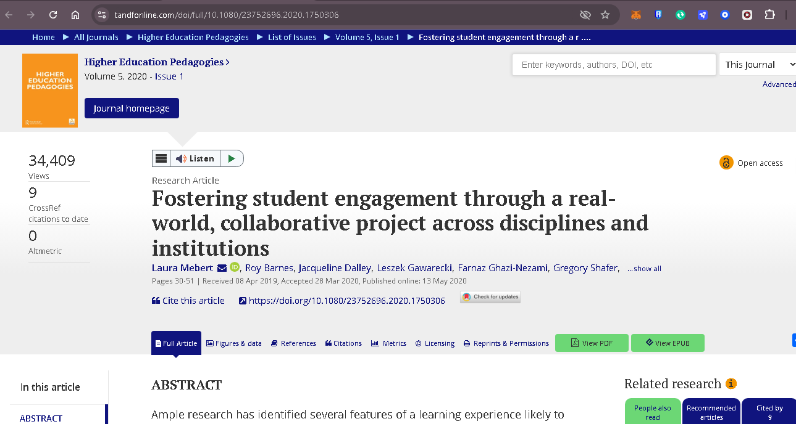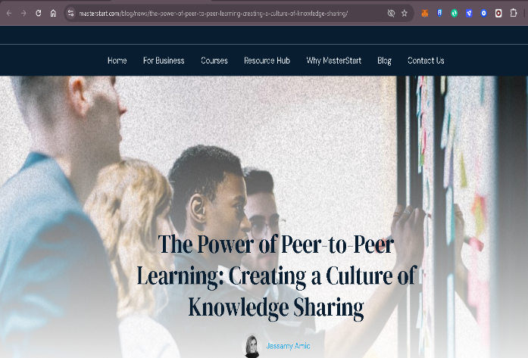**Screen Shot RRL**

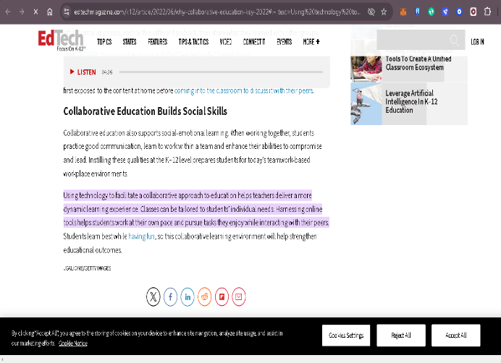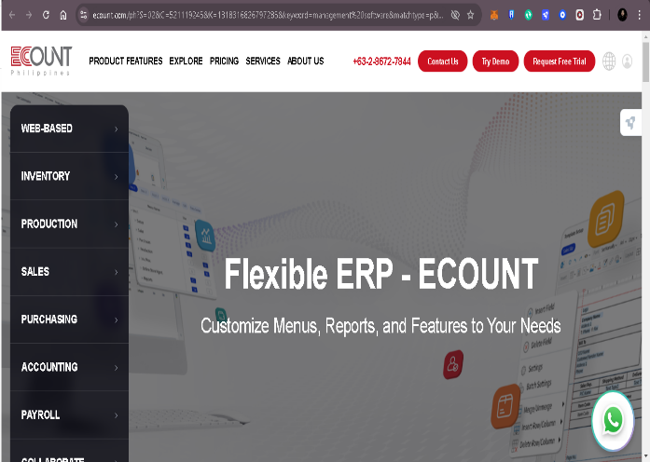

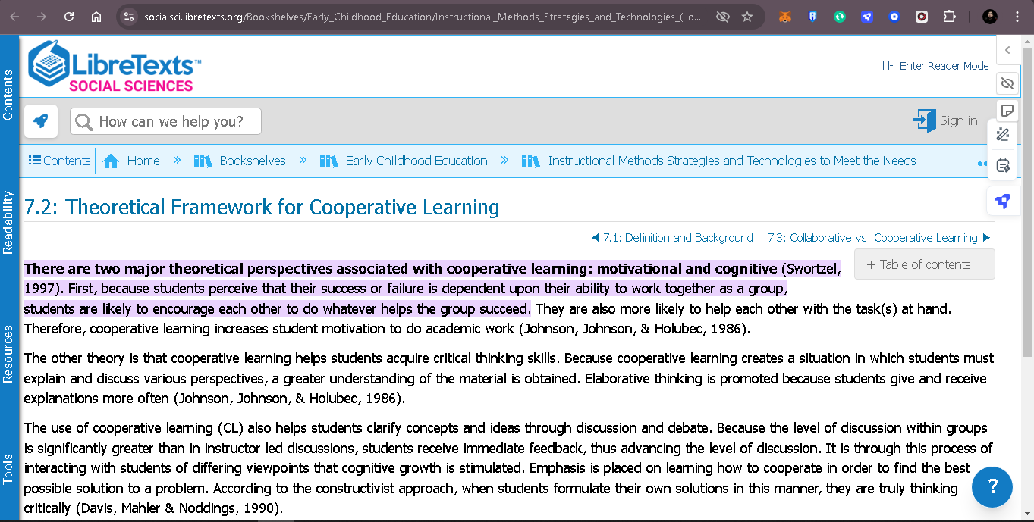

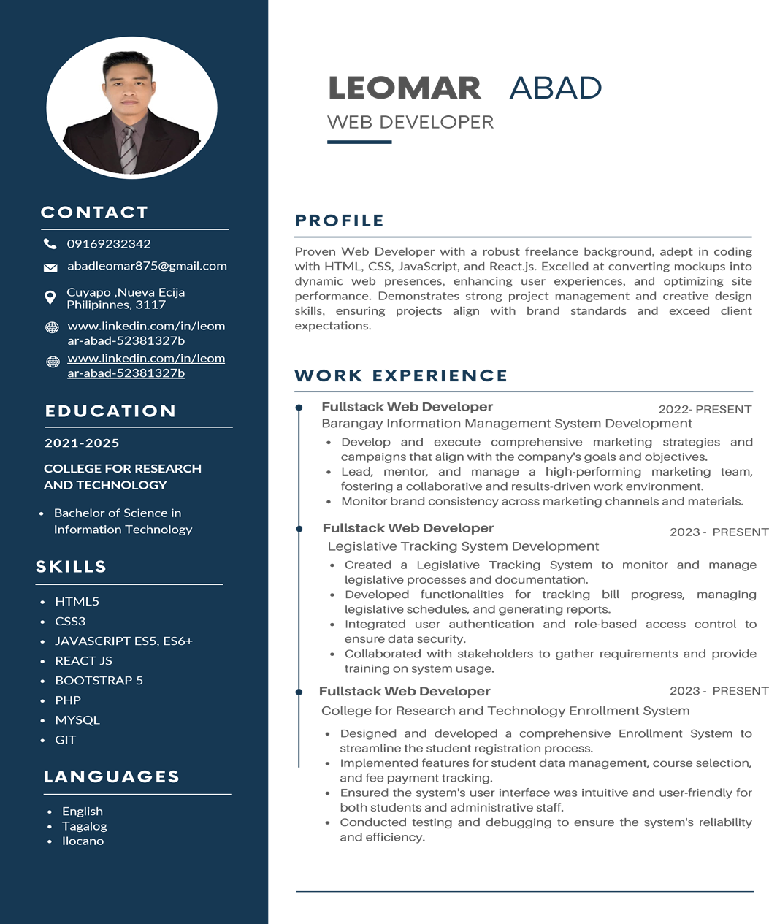**Resume**

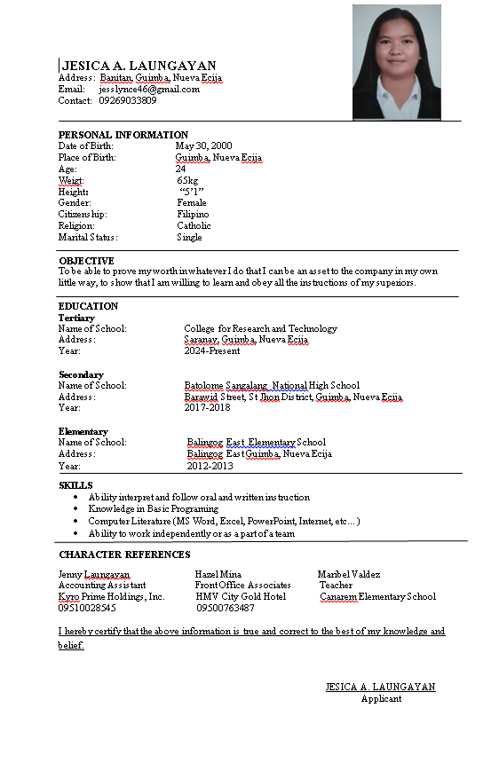

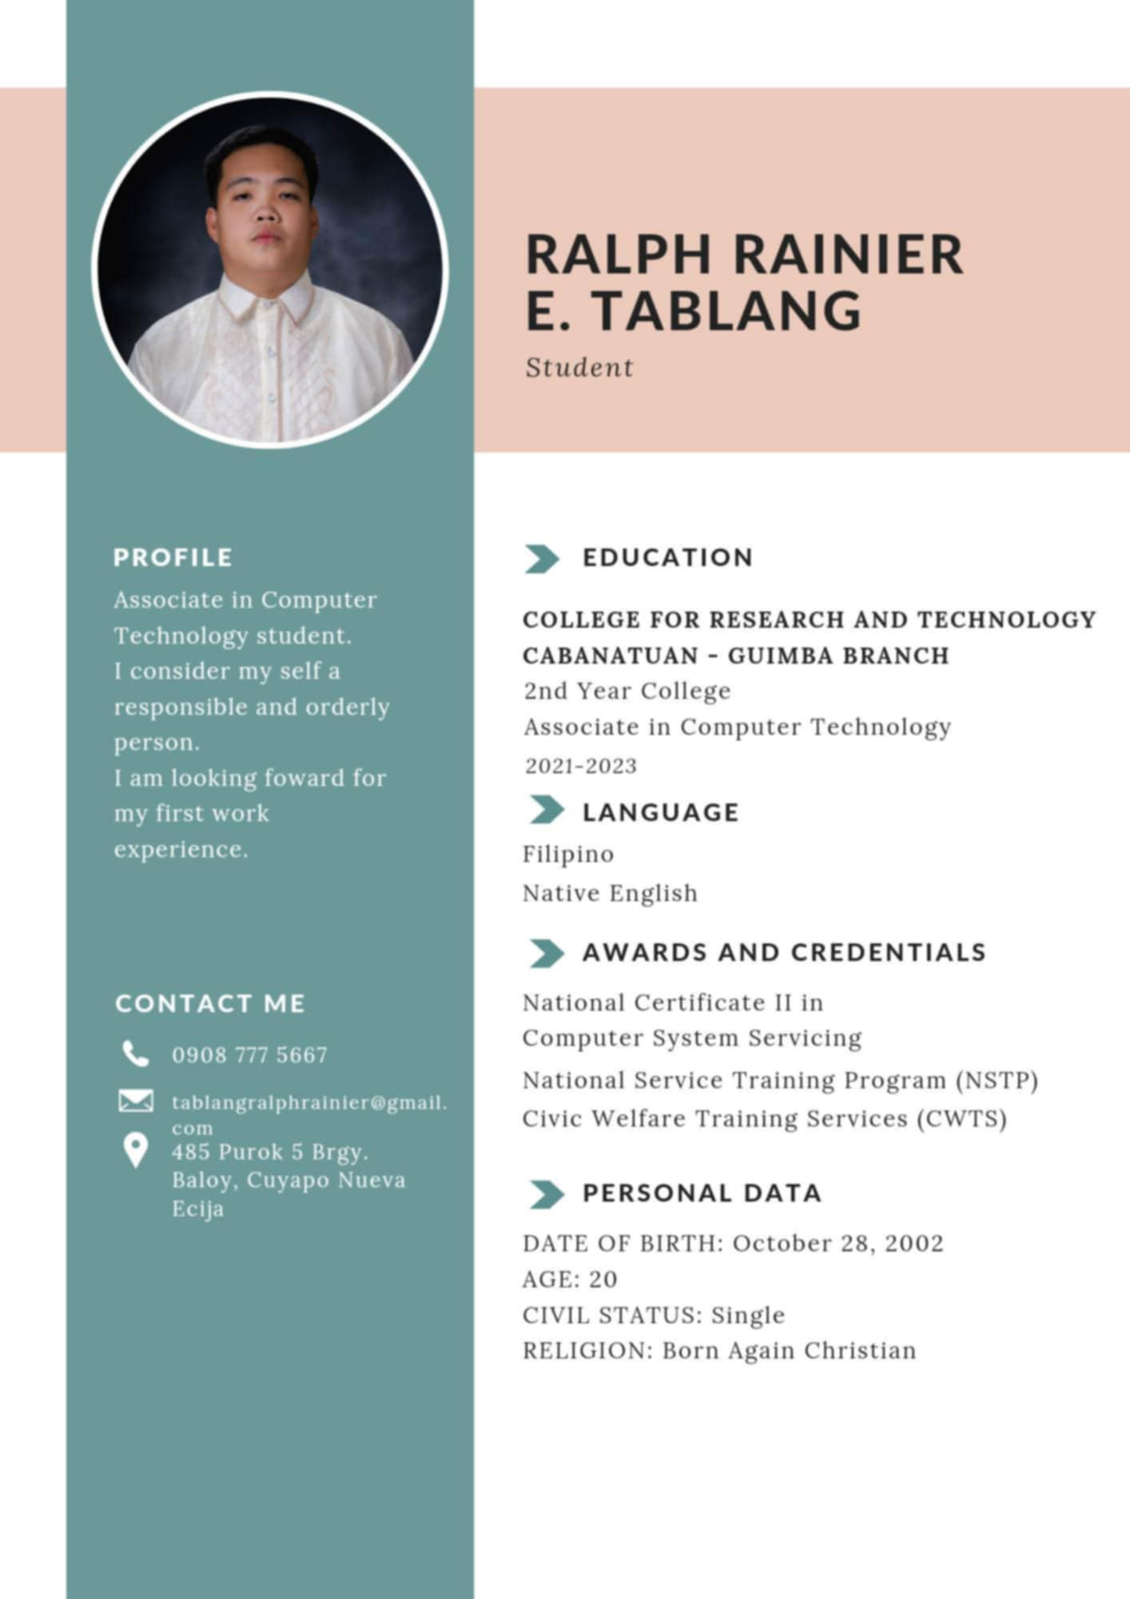



**ORLAN JAMES G. STA ANA**

#003 Partida 1st Guimba Nueva Ecija

Contact No.: 09758101597

Email: ojstaana@gmail.com

**OBJECTIVE:**

An enthusiastic job seeker with the goal to expand the skills and knowledge when it comes to the field of sales and customer service.

**PERSONAL DATA:**

**Date of Birth:** February 08, 1993

**Age:** 30

**Citizenship:** Filipino

**Sex:** Male

**Civil Status:** Married

**Height:** 5’6

**Weight:** 85 kls

**Religion:** Iglesia ni Cristo

**Language:** Tagalog and English

**Father:** Orlando Sta Ana

**Mother:** Shirley Sta Ana

|  |  |  |
| --- | --- | --- |
| **EDUCATIONAL ATTAINMENT:** | | |
| **College** | College for Research and Technology of Cabanatuan City | Graduated  2021-2023 |
| **Secondary** | Galvan High School  Galvan, Guimba, Nueva Ecija | 2008 - 2009 |
| **Elementary** | Galvan Elementary School  Galvan, Guimba, Nueva Ecija | 2004 - 2005 |

*hereby certify that the information above is true and correct to the best of my knowledge and belief.*

**ORLAN JAMES G. STA ANA**

*Applicant*

**SANTOS R. GARCIA III**Puro2 Cawayan Bugtong Guimba Nueva Ecija

Contact No.: 09952651465

Email: santosgarciaiii2112@gmail.com

**OBJECTIVE:**

An enthusiastic job seeker with the goal to expand the skills and knowledge when it comes to the field of sales and customer service. With the use of technological capabilities in terms of computer software and other devices that have been adapted from past work experiences such as production staff, pump attendant and cashier which will benefit an individual to excel in the field of customer service and fast-paced work environment, which most of the companies are searching for.

**PERSONAL DATA:**

**Date of Birth:** September 21, 2000

**Citizenship:** Filipino

**Sex:** Male

**Civil Status:** Single

**Height:** 5’9

**Weight: 70** kls

**Religion:** Iglesia ni Cristo

**Language:** Tagalog and English

**Father:** Santos Garcia Sr

**Mother:** Fe Garcia

|  |  |  |
| --- | --- | --- |
| **EDUCATIONAL ATTAINMENT:** | | |
| **College** | Collage for Research and Technology | 2021 - 2023 |
| **Secondary** | Bartolome Sangalang National High School | 2015 - 2016 |
| **Elementary** | Cawayan Bugtong Elementary School | 2012 - 2015 |

*I hereby certify that the information above are true and correct to the best of my knowledge and belief.*

**Santos R. Garcia III**

*Applicant*